Main GUI:
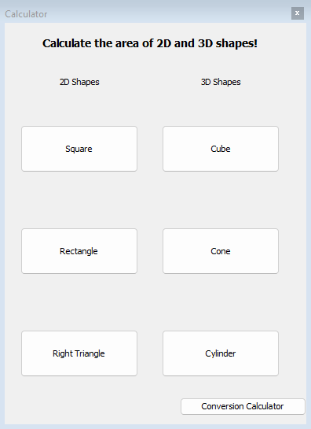

Square GUI Pop-up:
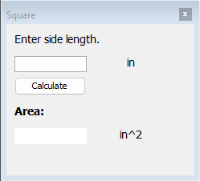
Rectangle GUI Pop-up:
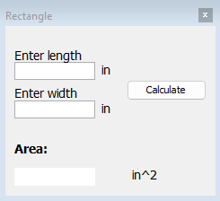

Right Triangle GUI Pop-up:
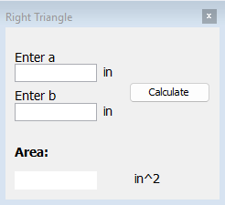
Cube GUI Pop-up:
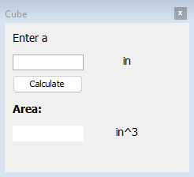

Cone GUI Pop-up:
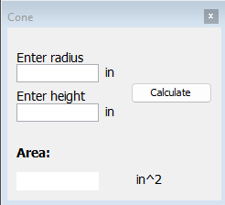
Cylinder GUI Pop-up:
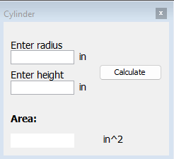

Conversion Calculator (Main GUI)
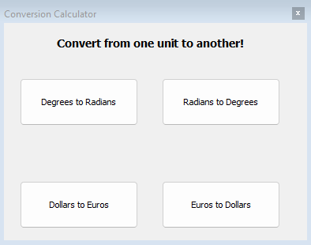
Degrees to Radians
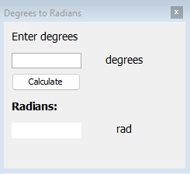

Radians to Degrees
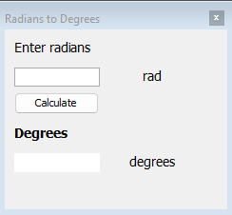
Dollars to Euros
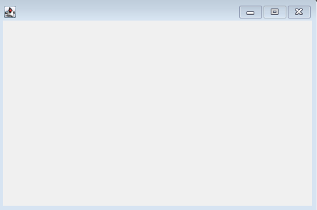

Euros to Dollars
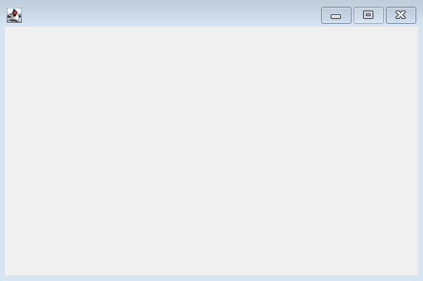
11th Button Idea:
Currency calculator that allows the user to convert multiple types of currency (yen, euros, pesos, dollars, Canadian dollars, etc.). The user should be able to select the type of currency and what they would like to convert to using a drop-down box. The output will be calculated by pressing a button “Calculate” and the output will be displayed in a text field along with the symbol of the currency ($ for dollars, ¥ for yen, etc.)

